Name: **Uday Singh** Mark _____________________/50

**Note:** I have also uploaded all the required diagrams in the separate folder of this champion document for reference.

## Brief introduction __/3

"In-Between" is an action-adventure video game inspired by *The Binding of Isaac*, featuring roguelike elements, exploration, and intense combat. As part of the development team, I am responsible for designing and implementing key game interface elements including the **Inventory**, **HUD (Heads-Up Display)**, **Main Menu**, and **Pause Menu**. These features are crucial to enhancing the player's experience by providing intuitive, responsive, and accessible control over the game mechanics. The **Inventory** system allows players to manage their collected items, while the **HUD** provides real-time gameplay information such as health, score, and active items. The **Main Menu** offers essential navigation for starting, loading, and exiting the game, and the **Pause Menu** ensures players can take breaks or adjust settings without losing their progress. These components are integral to creating an immersive and user-friendly experience in the dynamic world of "In-Between".

## Use case diagram with scenario __14

**Use Case Diagram 1: Inventory/HUD System:**

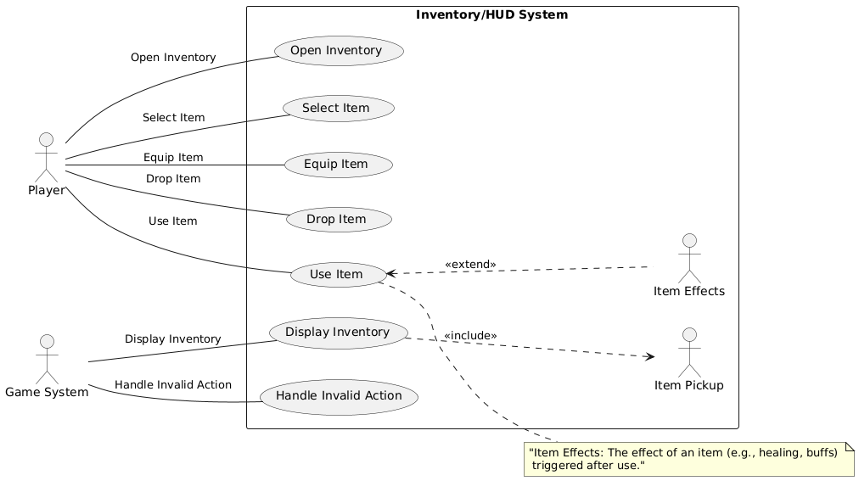

#### **Summary:**

The **Inventory/HUD System** enables the player to manage items, track health and stats, and interact with various HUD elements during gameplay. The **Inventory** manages the items collected, while the **HUD** provides real-time visual feedback, such as health, active items, and other gameplay details.

### ***Actors:***

1. **Player** (Primary Actor) - The user interacting with the inventory and HUD system during gameplay.
2. **Game System** (Secondary Actor) - Handles the game logic and updates the HUD with information like health, item status, etc.

### ***Preconditions:***

* The player has started the game and is actively playing.
* The player has collected at least one item.

### ***Use Cases:***

1. **View Inventory**
   1. **Description:** The player can open the inventory menu to see the items they have collected.
      1. **Basic Sequence:**
         1. Player presses the inventory button/key.
         2. Game displays the inventory interface.
         3. Player can select and view items.
2. **Equip Item**
3. **Description:** The player can equip an item from the inventory (e.g., weapons, armor).
   * 1. **Basic Sequence:**
        1. Player selects an item in the inventory.
        2. Player clicks/equips the item.
        3. The item is applied to the player's character, and the HUD updates accordingly (e.g., showing equipped weapon/armor).
4. **Use Item**
   1. **Description:** The player can use an item from the inventory (e.g., health potion).
      1. **Basic Sequence:**
         1. Player selects an item in the inventory.
         2. Player chooses to use it (e.g., healing item).
         3. The player’s health is updated, and the item is removed from the inventory.
5. **View HUD**
   1. **Description:** The HUD continuously shows important game information such as health, score, and active item.
      1. **Basic Sequence:**
         1. Game continuously updates the HUD as the player interacts with the environment and progresses.
         2. The player can see their health bar, equipped items, and score at all times.

### ***Exceptions:***

1. **Inventory is Empty**
   1. **Basic Sequence Step:** When the player tries to open the inventory, but no items are collected.
   2. **Exception Behavior:** Display a message saying, "Inventory is empty."
2. **Cannot Equip Item (Invalid Item Type)**
   1. **Basic Sequence Step:** When the player tries to equip an item that cannot be equipped (e.g., a healing potion).
   2. **Exception Behavior:** Display a message, "This item cannot be equipped."

### ***Postconditions:***

* **Inventory:** After using or equipping an item, the inventory is updated with the remaining items.
* **HUD:** The HUD dynamically reflects changes such as health, equipped items, and any other gameplay stats.

### **Priority:**

* **Inventory:** Priority 1 (Must have)
* **HUD:** Priority 2 (Essential)

### ***ID:***

* **Inventory:** I01
* **HUD:** H01

### ***Use Case Diagram Relationships:***

* **<<include>>:**
  + **View Item Details:** When the player views an item in the inventory, this step is included.
* **<<extend>>:**
  + **Warning for Empty Inventory:** If the player tries to access the inventory when empty, this extends the "View Inventory" use case with an exception message.

**Use Case Diagram 2: HUD System:**

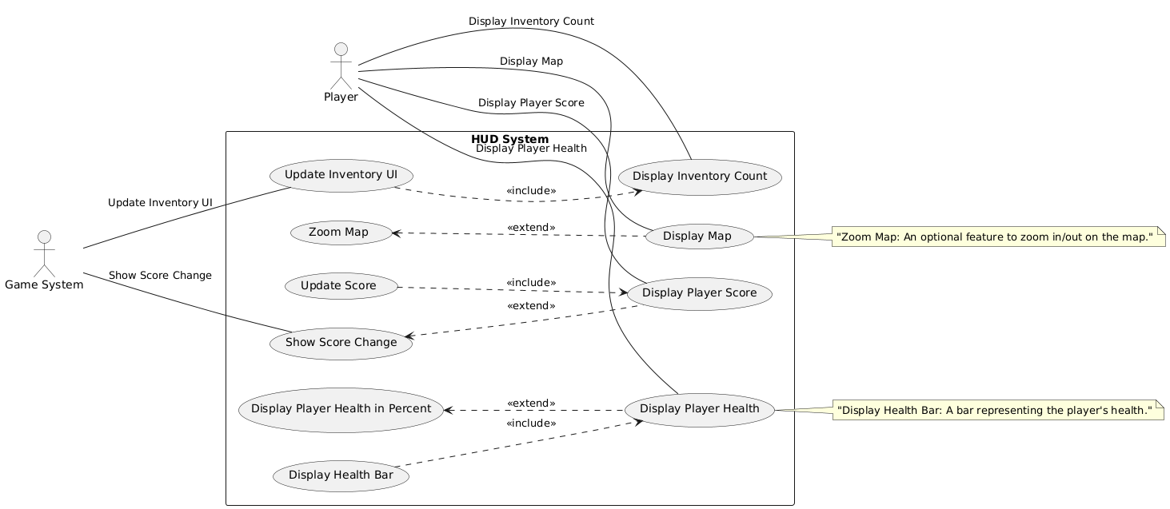

#### **Summary:**

The **HUD (Heads-Up Display)** provides essential, real-time information to the player during gameplay. This includes tracking the player's health, showing equipped items, displaying the score, and indicating any active effects (such as buffs or debuffs). The HUD is constantly updated based on game events, providing an immersive and informative experience.

### ***Actors:***

1. **Player** (Primary Actor) - The player interacts with the game and receives real-time feedback via the HUD.
2. **Game System** (Secondary Actor) - The system updates the HUD based on in-game events like health changes, item usage, and score updates.

### ***Preconditions:***

* The player has started the game and is actively playing.
* The game has initialized the HUD system.

### ***Use Cases:***

1. **Display Health** **Description:** The HUD displays the player's current health, showing a health bar or numerical value.
   1. **Basic Sequence:**
      1. The game system continuously tracks the player's health.
      2. The HUD updates to reflect changes in the player’s health.
      3. The player can see their current health status in real-time.
2. **Display Score** **Description:** The HUD shows the player's score, tracking progress or milestones in the game.
   1. **Basic Sequence:**
      1. The game system tracks the player’s score.
      2. The HUD updates to reflect the score, typically in a fixed position on the screen.
      3. The player can always view the score, providing a sense of progression.
3. **Display Equipped Items** **Description:** The HUD shows which items are currently equipped (e.g., weapons, armor).
   1. **Basic Sequence:**
      1. The player equips an item from the inventory.
      2. The game system updates the HUD to reflect the item’s effect.
      3. The player can see the currently equipped items on the HUD (e.g., weapon in use).
4. **Display Active Effects (Buffs/Debuffs)** **Description:** The HUD shows any active effects, such as buffs or debuffs, affecting the player.
   1. **Basic Sequence:**
      1. The game system tracks buffs/debuffs (e.g., speed boost, poison effect).
      2. The HUD updates to reflect these effects, showing icons or timers.
      3. The player can monitor the effects in real-time.
5. **Display Timer/Countdown** **Description:** The HUD displays a timer or countdown for certain game events (e.g., time-limited missions).
   1. **Basic Sequence:**
      1. The game system tracks the countdown.
      2. The HUD displays the countdown timer.
      3. The player can see the remaining time for specific events.

### ***Exceptions:***

1. **Health Depleted**
   1. **Basic Sequence Step:** When the player’s health reaches zero.
   2. **Exception Behavior:** Display a "Game Over" message on the HUD or trigger a transition to a respawn screen.
2. **Score Update Fail**
   1. **Basic Sequence Step:** When the score fails to update due to a system error.
   2. **Exception Behavior:** Display a message: "Score Update Failed."
3. **HUD Glitch (Incorrect Display)**
   1. **Basic Sequence Step:** When the HUD fails to display the correct information (e.g., health or item count).
   2. **Exception Behavior:** A fallback HUD interface is shown until the issue is resolved.

### ***Postconditions:***

* The **Health**, **Score**, **Equipped Items**, **Active Effects**, and **Timers** are continuously updated during gameplay.
* Any changes to the player's state (health, score, effects) are accurately reflected in the HUD.

### ***Priority:***

* **Health Display:** Priority 1 (Must have)
* **Score Display:** Priority 2 (Essential)
* **Equipped Items Display:** Priority 2 (Essential)
* **Active Effects Display:** Priority 3 (Nice to have)
* **Timer/Countdown:** Priority 3 (Nice to have)

### ***ID:***

* **Health Display:** H01
* **Score Display:** H02
* **Equipped Items Display:** H03
* **Active Effects Display:** H04
* **Timer/Countdown:** H05

### ***Use Case Diagram Relationships:***

* **<<include>>:**
  + **Update Health Display**: The health is updated dynamically based on the player’s health changes, and this is included in the "Display Health" use case.
* **<<extend>>:**
  + **Display Warning for Low Health:** This extends the "Display Health" case when the player’s health drops below a certain threshold (e.g., 20%).
  + **Display Buff/Debuff Icons:** When active buffs or debuffs are applied, this extends the "Display Active Effects" use case.

**Use Case Diagram 3: Main Menu and Pause Menu System:**

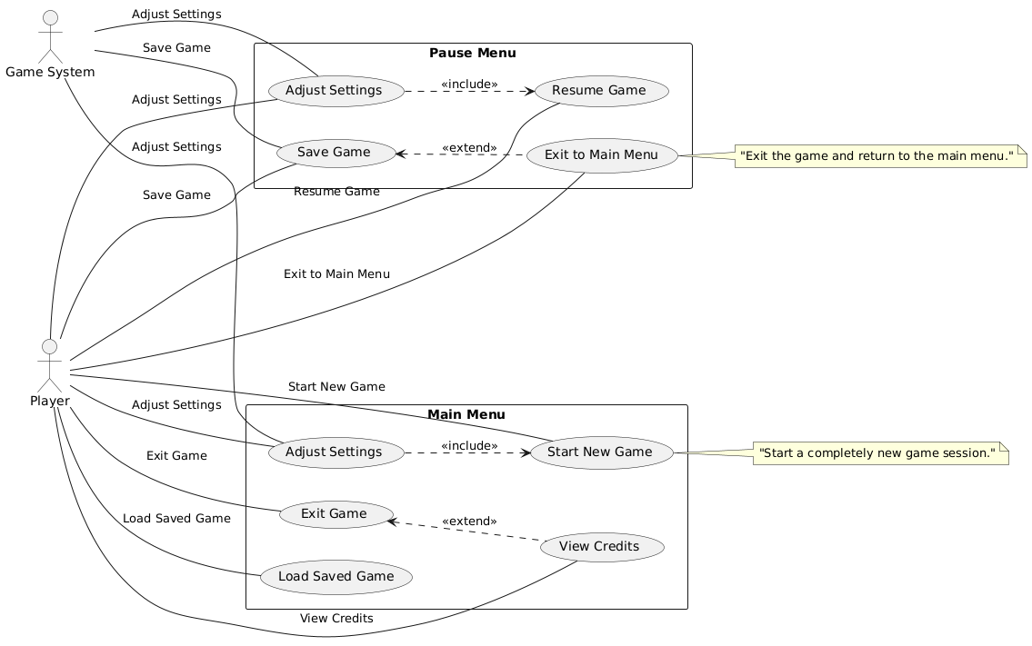

#### **Summary:**

The **Main Menu** and **Pause Menu** provide essential navigation and control to the player. The **Main Menu** appears when the game is launched, offering the player options to start, load, or quit the game. The **Pause Menu** is accessed during gameplay and allows the player to pause the game, adjust settings, or exit the game.

### ***Actors:***

1. **Player** (Primary Actor) - The player interacts with both menus to control the flow of the game.
2. **Game System** (Secondary Actor) - The game system reacts to the player's menu choices, either starting the game, saving progress, or pausing the game.

### ***Preconditions:***

* The game has been launched or is currently running.
* The game is either in the **Main Menu** (at launch) or in-game and paused.

### ***Use Cases:***

1. **Main Menu Options** **Description:** When the game starts, the main menu presents the following options: Start New Game, Load Game, Settings, and Exit.
   1. **Basic Sequence:**
      1. The game presents the main menu options.
      2. The player selects an option (e.g., Start New Game).
      3. The game starts the chosen action (start a new game, load a saved game, adjust settings, or exit).
2. **Start New Game** **Description:** The player selects this option to start a new game.
   1. **Basic Sequence:**
      1. The player selects the "Start New Game" option from the main menu.
      2. The game system initializes the game world.
      3. The player is transported to the beginning of the game.
3. **Load Game** **Description:** The player selects this option to load a saved game.
   1. **Basic Sequence:**
      1. The player selects "Load Game" from the main menu.
      2. The game displays a list of available saved games.
      3. The player selects a saved game, and the game loads the saved progress.
4. **Settings** **Description:** The player selects this option to adjust game settings (e.g., volume, graphics, controls).
   1. **Basic Sequence:**
      1. The player selects "Settings" from the main menu.
      2. The game presents a menu for adjusting various settings.
      3. The player modifies the settings and confirms.
      4. The game saves and applies the changes.
5. **Exit Game** **Description:** The player selects this option to quit the game and close the application.
   1. **Basic Sequence:**
      1. The player selects "Exit" from the main menu.
      2. The game prompts the player to confirm the exit.
      3. The game closes the application.
6. **Pause Game** **Description:** During gameplay, the player can pause the game to access the Pause Menu.
   1. **Basic Sequence:**
      1. The player presses the pause button (e.g., ESC).
      2. The game freezes, and the Pause Menu is displayed.
      3. The player can choose to resume, adjust settings, or return to the main menu.
7. **Resume Game** **Description:** The player can resume the game after pausing it.
   1. **Basic Sequence:**
      1. The player selects the "Resume Game" option from the pause menu.
      2. The game unpauses, and the player returns to gameplay.
8. **Pause Menu Options** **Description:** The pause menu provides options to resume the game, change settings, or quit to the main menu.
   1. **Basic Sequence:**
      1. The game displays the pause menu with various options.
      2. The player selects an option (e.g., Resume, Settings, Quit to Main Menu).
      3. The game performs the selected action (resumes gameplay, opens settings, or returns to the main menu).

### ***Exceptions:***

1. **Invalid Option in Main Menu**
   1. **Basic Sequence Step:** When the player selects an invalid or unavailable option.
   2. **Exception Behavior:** Display a warning message ("Invalid Option Selected") and allow the player to choose again.
2. **Save File Not Found**
   1. **Basic Sequence Step:** When the player selects "Load Game," but no saved games are available.
   2. **Exception Behavior:** Display a message: "No saved games found. Start a new game?"
3. **Pause Menu Interaction Failure**
   1. **Basic Sequence Step:** If the player tries to interact with the pause menu when the game is not paused.
   2. **Exception Behavior:** Display a warning message or disable pause options.
4. **Settings Change Conflict**
   1. **Basic Sequence Step:** When two conflicting settings are changed (e.g., both graphics and resolution set to incompatible values).
   2. **Exception Behavior:** Notify the player of the conflict and revert the settings or ask for confirmation.

### ***Postconditions:***

* The **Main Menu** and **Pause Menu** will always be accessible during their respective states.
* The game state (whether running or paused) will be managed appropriately.
* Any settings changes will be saved and applied.
* The player’s progress (if applicable) will be saved after selecting "Load Game."

### ***Priority:***

* **Main Menu Options:** Priority 1 (Must have)
* **Pause Menu Options:** Priority 2 (Essential)
* **Settings Menu:** Priority 2 (Essential)
* **Exit Game:** Priority 2 (Essential)
* **Load Game:** Priority 2 (Essential)
* **Start New Game:** Priority 1 (Must have)
* **Resume Game:** Priority 1 (Must have)

### ***ID:***

* **Main Menu Options:** M01
* **Start New Game:** M02
* **Load Game:** M03
* **Settings:** M04
* **Exit Game:** M05
* **Pause Game:** P01
* **Resume Game:** P02
* **Pause Menu Options:** P03

### ***Use Case Diagram Relationships:***

* **<<include>>:**
  + **Start New Game:** This is always included when the player selects the "Start New Game" option in the main menu.
* **<<extend>>:**
  + **Settings Change Conflict:** This extends the "Settings" use case when conflicting settings are detected.
  + **Display Save Confirmation:** This extends the "Load Game" use case when the game needs to confirm that a save file exists.

## Data Flow diagram(s) from Level 0 to process description for your feature _______14

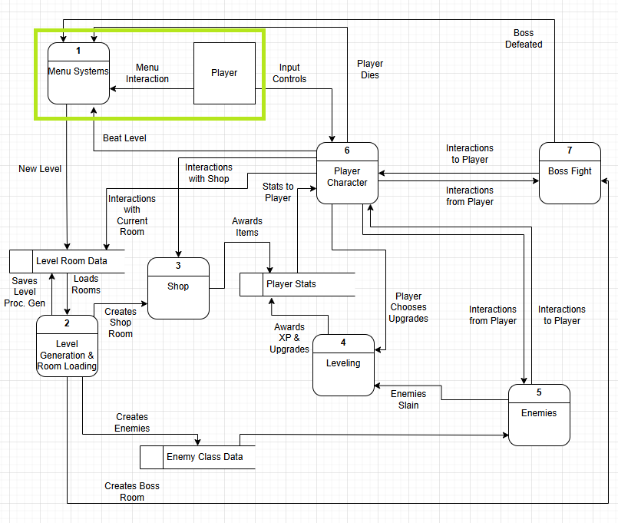

**Diagram 0 for ‘In-Between’ Video Game**

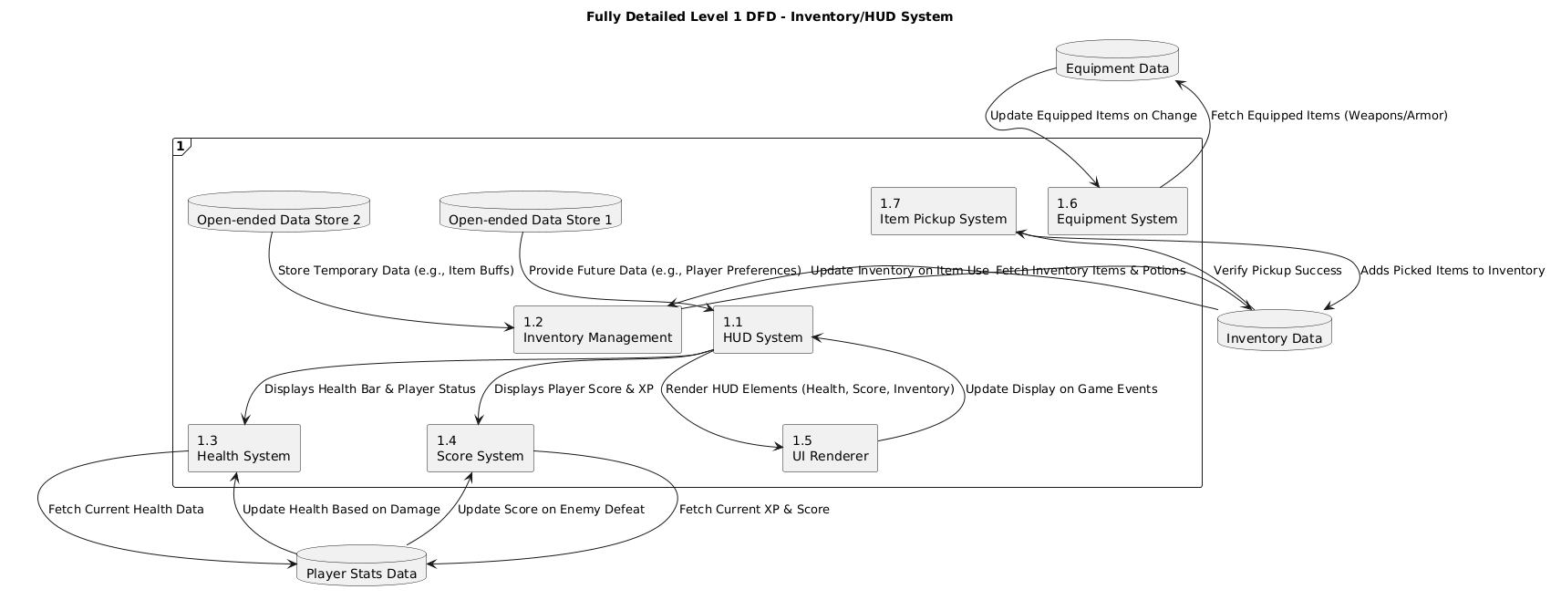

## Level 1 Diagram: HUD/Inventory System

***Process Description: Inventory / HUD System:***

#### **Purpose:**

The **Inventory and HUD System** in *InBetween* allows players to manage their collected items and provides real-time game data, such as health, energy, and quest progress. These systems work together to ensure players can make strategic decisions while keeping track of their status.

#### **Process Flow:**

1. **Opening Inventory:**
   1. When the player opens the inventory (e.g., pressing "I"), the **Inventory System** displays the available items (weapons, health potions, etc.).
   2. Simultaneously, the **HUD** displays essential information (e.g., health bar, current currency, quest objectives) in the background.
2. **Item Selection and Usage:**
   1. The player selects an item from the inventory (e.g., a health potion).
   2. The **Inventory System** updates the item count.
   3. The **HUD** updates immediately, reflecting changes like health restoration, energy depletion, or quest progress.
3. **Inventory Management:**
   1. The player can equip, use, or discard items. For instance, equipping a weapon updates the **HUD** to show the new weapon’s effects.
   2. The **HUD** shows current stats (health, mana, etc.), which change as items are used.
4. **Dynamic Feedback:**
   1. As items are used or collected, the **HUD** provides instant feedback. For example, using a health potion will update the health bar on the HUD, and the inventory count will decrease.
5. **Closing Inventory:**
   1. When the player closes the inventory, the game world resumes, but the **HUD** continues to provide real-time updates on the player’s status.

#### **Output:**

* **Inventory System**: Displays item information and updates inventory counts as items are used or added.
* **HUD System**: Continuously shows real-time player stats (health, mana, currency) and updates based on inventory actions (e.g., health restoration, item usage).

#### **Integration:**

* The **Inventory** updates dynamically as the player uses or interacts with items.
* The **HUD** reflects these updates in real time, showing health, item counts, and quest status.

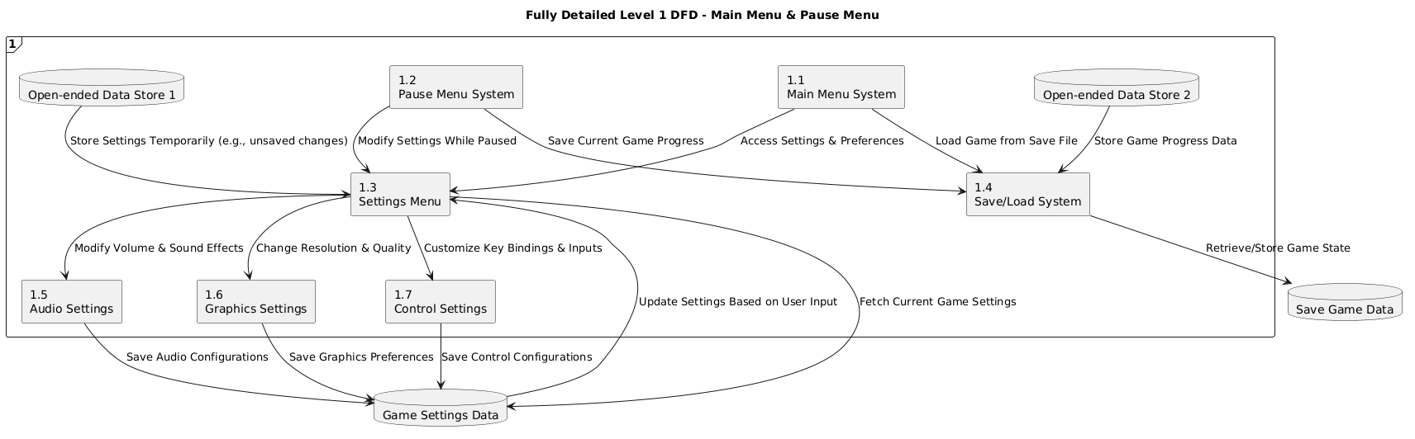

**Level 1 Diagram: Main menu and Pause Menu**

***Main Menu and Pause Menu Process Description:***

#### **Purpose:**

The **Main Menu** and **Pause Menu** provide players with essential controls and options to interact with the game. The **Main Menu** serves as the entry point to start, load, or quit the game, while the **Pause Menu** allows players to temporarily halt the game to adjust settings, resume play, or exit.

#### **Process Flow:**

1. **Main Menu Initialization:**
   1. When the game starts, the **Main Menu** appears, offering options like "Start New Game", "Load Game", "Options", and "Exit".
   2. **HUD and Inventory** are not displayed in the Main Menu, and the game is inactive.
2. **Selecting Options:**
   1. Players can select any option:
      1. **Start New Game**: Resets the game and starts from the beginning.
      2. **Load Game**: Opens a save file and resumes from the last save point.
      3. **Options**: Opens game settings (e.g., sound, controls, graphics).
      4. **Exit**: Closes the game.

After selecting an option, the menu transitions to the corresponding action (e.g., loading a game or starting a new one).

1. **Pause Menu Activation:**
   1. During gameplay, the **Pause Menu** can be triggered by pressing a designated pause button (e.g., "Esc").
   2. The **HUD** remains visible in the background, showing player stats, but the game is paused, and no actions or movement can occur until the player resumes or exits.
2. **Pause Menu Options:**
   1. **Resume Game**: Returns the player to gameplay, restoring game state and reactivating the **HUD**.
   2. **Options**: Allows players to adjust settings while the game is paused (e.g., sound, controls).
   3. **Save Game**: Saves progress at the current point.
   4. **Exit to Main Menu**: Takes the player back to the Main Menu, where they can choose other actions like starting a new game or loading a previous save.
3. **Closing Menus:**
   1. Players can exit the **Pause Menu** by selecting "Resume Game", which brings them back to gameplay.
   2. If the **Main Menu** is selected, the game will either exit, load, or reset, depending on the choice.

#### **Output:**

* **Main Menu**: Provides a clear selection of game options and controls.
* **Pause Menu**: Pauses the game and provides options for saving, adjusting settings, or resuming play.

#### **Integration:**

* The **Pause Menu** temporarily halts gameplay while preserving the player's current state, allowing for immediate continuation or interaction with the game’s settings.
* The **Main Menu** serves as a starting point for accessing the game’s core features, including starting a new game, loading, or exiting.

## Acceptance Tests ________9

**Acceptance Tests for Inventory and HUD System:**

#### **Test 1: Inventory Item Usage**

* **Input:** Use a health potion from the inventory.
* **Expected Output:** Inventory count decreases by 1, and health bar increases by a predefined amount (e.g., +20 health).
* **Boundary Case:**
  + Health cannot exceed max value.
  + Cannot use health potion if none are available.

#### **Test 2: Display and Update HUD Stats**

* **Input:** Change player's health, energy, or currency during gameplay.
* **Expected Output:** HUD updates to reflect changes in health, energy, and currency in real time.
* **Boundary Case:**
  + Health reaches 0 (player death or failure).
  + Currency exceeds the maximum value.

#### **Test 3: Inventory Full Capacity**

* **Input:** Try to add items when the inventory is full.
* **Expected Output:** Inventory should prevent further items from being added, and a message should appear ("Inventory full").
* **Boundary Case:**
  + Inventory prevents adding more items once full.
  + Correct behavior when trying to add an item beyond the capacity.

#### **Test 4: Switching Items in Inventory**

* **Input:** Equip a new weapon or item from inventory.
* **Expected Output:** Inventory marks the equipped item, and HUD updates to reflect changes (e.g., new weapon stats).
* **Boundary Case:**
  + Equip a non-functional item and ensure HUD displays it correctly.
  + Equip special items (e.g., shield) and check HUD update.

|  |  |  |  |  |
| --- | --- | --- | --- | --- |
| **Test ID** | **Description** | **Input** | **Expected Output** | **Boundary Case** |
| IHS-01 | Open Inventory | Open inventory | Inventory screen appears | No items = empty inventory |
| IHS-01 | Add Item | Add health potion | Item appears in inventory | Inventory slots full |
| IHS-05 | Use Item | Use health potion | Health increases, item removed | Max health not exceeded |

**Acceptance Tests for Main Menu and Pause Menu System:**

#### **Test 1: Main Menu Navigation:**

* **Input:** Start the game and navigate through the main menu options (Start Game, Load Game, Settings, Exit).
* **Expected Output:** Main menu displays correctly, and selecting an option navigates to the appropriate screen (Start Game launches the game, Load Game opens saved files, etc.).
* **Boundary Case:**
  + Selecting "Load Game" only works if a saved game exists.
  + Ensure the "Exit" button closes the game cleanly.

#### **Test 2: Pause Menu Functionality:**

* **Input:** While in-game, press the designated pause button to open the pause menu.
* **Expected Output:** Pause menu appears with options like Resume, Save Game, Settings, and Exit to Main Menu.
* **Boundary Case:**
  + Selecting "Resume" should return to gameplay without issues.
  + Selecting "Exit to Main Menu" should take the player to the main menu and save progress if necessary.

#### **Test 3: Save/Load Functionality in Pause Menu**

* **Input:** While paused, select "Save Game" and then resume gameplay. After gameplay, pause and select "Load Game."
* **Expected Output:** Game progress should be saved correctly when "Save Game" is selected, and "Load Game" should restore the correct saved state.
* **Boundary Case:**
  + If no saved games exist, "Load Game" should display an appropriate message (e.g., "No saved games found").
  + Ensure that overwriting saved games works as expected.

#### **Test 4: Pause Menu Settings Option:**

* **Input:** From the pause menu, select "Settings" to adjust game settings (e.g., volume, difficulty).
* **Expected Output:** The settings menu opens and allows for adjustments. Settings should be saved and applied immediately.
* **Boundary Case:**
  + Ensure changes like volume adjustments take effect immediately.
  + Test with extreme values for settings (e.g., maximum volume, minimum difficulty).

#### **Test 5: Invalid Option in Pause Menu:**

* **Input:** In the pause menu, try selecting an invalid or unavailable option (e.g., press a disabled button).
* **Expected Output:** The game should ignore the invalid selection without crashing or showing any errors.
* **Boundary Case:**
  + Test that selecting a disabled button or unavailable option (like "Quit to Desktop") does not cause any crashes or unintended behavior.

#### **Test 6: Main Menu Transition After Pausing:**

* **Input:** During gameplay, open the pause menu and select "Exit to Main Menu."
* **Expected Output:** The game should transition back to the main menu, ensuring the game state is either saved or prompted to save before exiting.
* **Boundary Case:**
  + Ensure that unsaved progress prompts the player to confirm saving before exiting.

|  |  |  |  |  |
| --- | --- | --- | --- | --- |
| **Test ID** | **Description** | **Input** | **Expected Output** | **Boundary Case** |
| MM/PM-01 | Main Menu Navigation | Navigate through options | Correct screen navigated | "No saved games" message |
| MM/PM-03 | Save Game | Select "Save Game" | Game state saved | No save file = prompt |
| MM/PM-06 | Exit to Main Menu | Select "Exit to Main Menu" | Returns to main menu | No unsaved progress lost |

## Timeline _________/10

***Work Items:***

|  |  |  |  |  |  |  |  |  |
| --- | --- | --- | --- | --- | --- | --- | --- | --- |
| **Task #** | **Task Description** | **Estimated Duration (Hours)** | **Predecessor Tasks** | **Early Start (ES)** | **Early Finish (EF)** | **Late Start (LS)** | **Late Finish (LF)** | **Slack Time (Hours)** |
| 1 | Requirement collection | 2 | - | 0 | 2 | 0 | 2 | 0 |
| 2 | System design | 4 | 1 | 2 | 6 | 3 | 7 | 1 |
| 3 | Database setup | 2 | 2 | 6 | 8 | 7 | 9 | 1 |
| 4 | Main menu and pause menu development | 4 | 2 | 6 | 10 | 9 | 13 | 3 |
| 5 | HUD and inventory system development | 6 | 2 | 6 | 12 | 7 | 13 | 5 |
| 6 | Save and load functionality | 4 | 4 | 10 | 14 | 13 | 17 | 3 |
| 7 | Settings menu and preferences | 3 | 2 | 6 | 9 | 10 | 13 | 4 |
| 8 | Programming- main logic | 12 | 5,6,7 | 12 | 24 | 13 | 25 | 1 |
| 9 | Testing | 5 | 8 | 24 | 29 | 25 | 30 | 0 |
| 10 | User documentation | 3 | 9 | 29 | 32 | 30 | 33 | 1 |
| 11 | Final integration and bug fixing | 3 | 9,10 | 32 | 35 | 33 | 36 | 1 |
| 12 | Installation and deployment | 2 | 11 | 35 | 37 | 36 | 38 | 1 |

***Pert Diagram:***

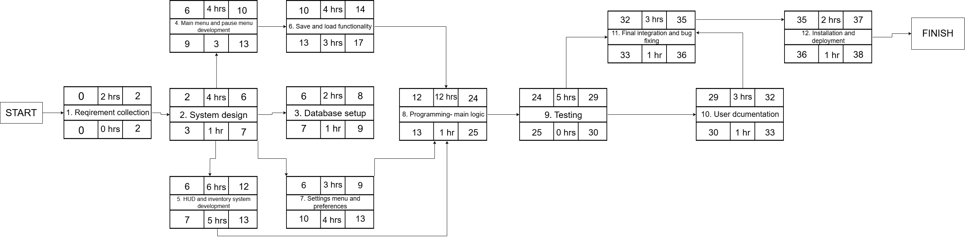

***Gantt Timeline:***

